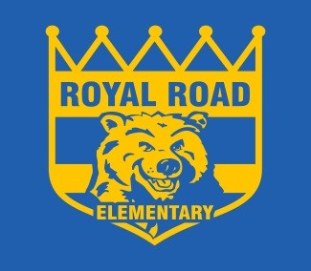
To Learn, To Grow, To Lead
Child’s Name Parent’s Name

“Getting to Know You”
- My child can be best described as:

- Has your child attended preschool or daycare? Yes No

If yes, which one?

- What are your child’s favourite toys, or books or activites?

- List important holidays and/or events that you celebrate. Are there any holidays you do not observe?

- Are there any allergies or medical conditions the school should be aware of?

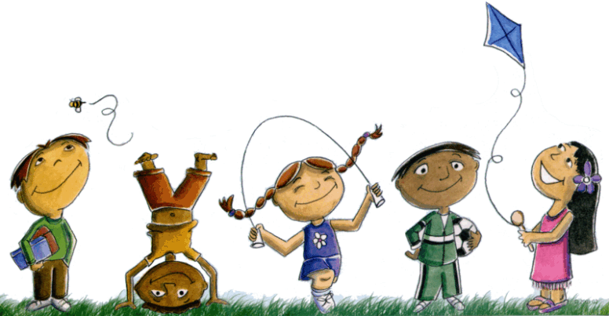

Child’s Name School

“Celebrating My Child”

My child can independently:

- Put on own coat
- Fasten own coat (for example, zippers or buttons)
- Put on shoes
- Use the washroom independently
- Print name without assistance
- Take turns
- Use scissors
- Hold attention/focus on an activity for 5 – 10 minutes
- Follow directions

If your child is still working on some of the skills, don’t worry. We just want to know where they are so we can help.

